**Commentary Markup is encouraged, but should be restricted to *only* i) emphasis (red, bold, underline, or font size), ii) bracketed [pink] commentary, and**

**iii) hypertext linking of a term or statement to a web page believed to offer quick uncontroversial augmentation.**

April 2, 2012 · 1:44 am

[↓ Jump to Comments](http://emsnews.wordpress.com/2012/04/02/time-for-an-honest-conversation-about-race-and-crime/#comments)

[**Time For An Honest Conversation About Race And Crime**](http://emsnews.wordpress.com/2012/04/02/time-for-an-honest-conversation-about-race-and-crime/)

A host of social and economic forces are colliding with ernest liberal guilt feelings to create a strange world that will end up with race wars raging out of control in all NATO countries.  This is very ironic since most political actions by NATO leaders has been to encourage ethnic/religious warfare in China or Muslim countries so they disintegrate.  The sins of the West in creating slavery and the kidnapping of millions of Africans in order to exploit their labor hang heavy on the heads of the Western powers.

But the mess this created in the past is causing society to collapse as social forces drive everyone into direct conflict.  It is mostly forbidden for us to discuss this honestly by both the right and left parties.  Just like discussions of the history of antisemitism and the Holocaust is nearly impossible without people responding in mindless ways, these historical sore spots cause a lot of distress and can’t be easily fixed without first trying to understand why it happened in the past and why things are not fixed today.

That is, the solutions are no solutions, they make things worse and being unable to discuss things rationally leads to more anger rather than finding a solution.  One thing is sadly certain: all of Africa needs better solutions, all of South and Central America, under the hammer of US coups and repressions and thefts and European enslavement and looting still reels from the hammer blows of the past while Africa is being actively destroyed to this day.

Meanwhile, the more the Chinese pull themselves out of their own destruction at the hands of their own past rulers and foreign invaders, the angrier the NATO leaders grow.  So, I am going to throw out a ton of statistics and some graphs today to discuss the disintegration of the black community in the US and how cries of racism are destroying blacks even as they feel the need to go on the attack to ‘stop racism’.

First, a good review of the past is this show: [Video: Slavery Full Program | Watch Slavery by Another Name Online | PBS Video](http://video.pbs.org/video/2176766758/).  That is, PBS has a nice review of Jim Crow which was a hideous system of abuse and power.  Of course, the video makes no mention of black slaves, once freed, didn’t rush out to become middle class families, there was a lot of lawlessness due to the fractured nature of ‘families’ when they were not allowed to be real families.

But the cruel neo-slave system set up to exploit the labor of any blacks arrested for even the most trivial reasons was a crime and it took the Civil Rights Act nearly 100 years later to fix it legally.  Once this happened, the black community in the US rushed out to finally join what was once white-only unions and neighborhoods only to see these collapse and die.

The internal collapse of the black community as this happened fixed it so the decline would be precipitous and pernicious.  It simply gets worse and worse each year.  For example, the right wing now allows blacks to own guns and Hispanic drug gangs are very much heavy users of firearms so there is a [General in the Pentagon suggesting that the U.S. may export terror war tactics to fight drug gangs](http://www.rawstory.com/rs/2012/03/30/general-u-s-may-export-terror-war-tactics-to-fight-drug-gangs/).

What we do in Mexico via proxies, we shall see here.  What we do to Afghanis directly is what we shall see here, too.  And the ‘tribal people’ who will be on the receiving end of the barrel of these military guns will be blacks and Hispanics.

The handwringing in both the US and UK over ‘race hate crimes’ has many ugly facets in particular, ‘protected’ minorities can commit openly racist crimes and get away with it in say, London:  [Muslim girl gang, who kicked Rhea Page in the head yelling ‘kill the white slag,’ FREED | Mail Online](http://www.dailymail.co.uk/news/article-2070562/Muslim-girl-gang-kicked-Rhea-Page-head-yelling-kill-white-slag-FREED.html)

A gang of Muslim women who attacked a passer-by in a city centre walked free from court after a judge heard they were ‘not used to being drunk’ because of their religion.

The group – three sisters and a cousin – allegedly screamed ‘kill the white slag’ as they set upon Rhea Page as she waited for a taxi with her boyfriend.

Miss Page, 22, was left with a bald patch where her hair was pulled out in the attack and was left ‘black and blue’ after suffering a flurry of kicks to the head, back, arms and legs while motionless on the pavement.

There is a great deal of ‘white rage’ over this story.  A surprising number of ‘minority’ young people are quite aware that they can do as they please to white people while no one can even cuss them out while they attack their victims.  Here is yet another example, like the story I linked to about the kid who was put in jail for joking about a black soccer player:  [‘Racist woman on a tram’ to spend Christmas behind bars ‘for own protection’ | Mail Online](http://www.dailymail.co.uk/news/article-2070647/Racist-woman-tram-spend-Christmas-bars-protection.html)

A woman accused of launching a vile racist rant on a tram is to spend Christmas behind bars after she was remanded in custody for her own safety.

Magistrates took the decision to refuse Emma West’s bail application after they heard she had received death threats and that her address had been circulated on social networking sites Facebook and Twitter.

The Daily Mail is the scruffy side of Fleet Street, and the mainstream media which is more ‘uptown’ are steadfastly ignoring these stories because it doesn’t fit the ‘narrative’.  That is, only whites are racist or mean.  The gangsta culture which is both male and female in black and Hispanic communities in the US knows they can play the race card to protect their criminal activities and this is why the demonstrations on behalf of the kid killed in Florida is so damaging: he was striving to ape gangsta street gangs and the black leadership in the US is demanding we not stop the garb, language or attitudes of gangsta blacks because we are ‘racist’ if we warn them to stop doing this.

Now for some graphs and statistics:  [www.colorofcrime.com/colorofcrime2005.pdf](http://www.colorofcrime.com/colorofcrime2005.pdf)

[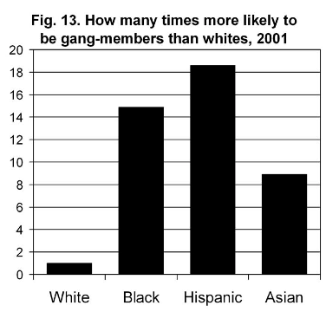](http://emsnews.files.wordpress.com/2012/04/screen-shot-2012-04-01-at-8-46-30-pm.png)

• Blacks are**seven times** more likely than people of other races to commit murder, and **eight times** more likely to commit robbery.  
• When blacks commit crimes of violence, they are nearly **three times** more likely than non-blacks to use a gun, and more than **twice as** likely to use a knife.  
• Hispanics commit violent crimes at roughly **three times** the white rate, and Asians commit violent crimes at about one quarter the white rate.  
• The single best indicator of violent crime levels in an area is the percentage of the population that is black and Hispanic.  
• Of the nearly 770,000 violent interracial crimes committed every year involving blacks and whites,**blacks commit 85 percent and whites commit 15 percent.**

• Blacks commit more violent crime against whites than against blacks. Forty- five percent of their victims are white, 43 percent are black, and 10 percent are Hispanic. **When whites commit violent crime, only three percent of their victims are black.**

• Blacks are an estimated **39 times** more likely to commit a violent crime against a white than vice versa, and **136 times** more likely to commit robbery.  
• Blacks are**2.25 times** more likely to commit officially-designated hate crimes against whites than vice versa.  
• Only 10 percent of youth gang members are white.  
• Hispanics are **19 times** more likely than whites to be members of youth gangs. Blacks are **15 times** more likely, and Asians are **nine times** more likely.

Interesting stats, no?  Because the victim of the Zimmerman vigilante killing was falsely portrayed as an innocent school child and not a boy who was suspended from school and left his mother’s house because he was being difficult, we didn’t have a national discussion about the pernicious nature of the media-fed gangsta culture and how it is rapidly destroying black youth even those who are in the black middle class.

Here is more from the crime study above:

The government’s treatment of hate crimes is misleading in one obvious way: Hispanics are a victim category but not a perpetrator category. If someone attacks a Mexican for racial reasons, he becomes a Hispanic victim of a hate crime. However, **if the same Mexican commits a hate crime against a black, he is classified as a “white” perpetrator.**  
Even more absurdly, **if a Mexican commits a hate crime against a white, both victim and perpetrator are reported as white**. And, in fact, the 2002 FBI figures—the most recent available—duly report that 130 so-called whites committed anti-white hate crimes. They are likely to have been Hispanics, but it is impossible to know. Sloppy racial categorization is particularly obtuse in a report that is supposed to shed light on the level and nature of racial friction.  
In 2002, there were 8,832 bias crimes reported to the FBI, of which 5,738 were crimes of race or ethnic origin. The rest were for reasons of religion, sexual orientation, or disability.46 The FBI says there were 5,119 suspected hate crime offenders whose race was known.

Of that number, 3,712 were W&H and 1,082 were black.  **It is widely believed that blacks are generally victims rather than perpetrators of hate crimes, but they are actually more likely than W&H to be offenders.** On the basis of offense rates—number of offenses divided by population— **blacks were 82 percent more likely than W&H to commit hate crimes of all kinds, including those based on religion, disability, etc.**

If this is true, then the black political collective should be lecturing black youth in particular about their own hate crimes, no?  Of course, the whole business of ‘Who is Zimmerman’ became very important since he couldn’t be considered a Hispanic or it would ruin the expression of wild rage being thrown at the white community.  Now on to some interesting graphs:

[Bureau of Justice Statistics Homicide trends in the U.S.: Intimate homicide](http://bjs.ojp.usdoj.gov/content/homicide/intimates.cfm#intgrel)

[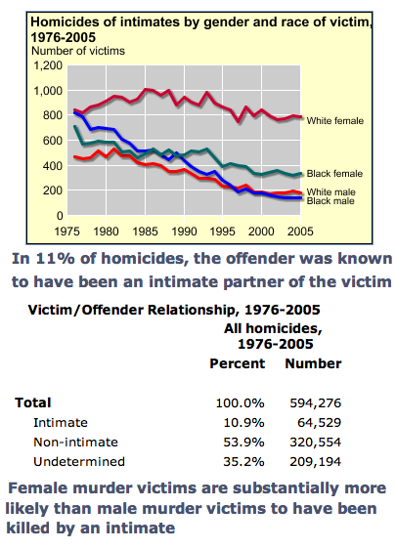](http://emsnews.files.wordpress.com/2012/04/homicide-by-gender-and-race.png)

Most homicide victims are white women.  We are attacked by intimate people we know, by strangers, by seemingly everyone.  As homicide rates of black and white males continues to fall (except where drug wars rage, of course), even black women have seen some fall though not as great, white women seem to suffer this the entire time with very little drop!  Seems like white females need more protection, no?

[CRIME RATE AND CONVICTION RATES BROKEN DOWN BY RACE](http://www.cga.ct.gov/2008/rpt/2008-R-0008.htm)

[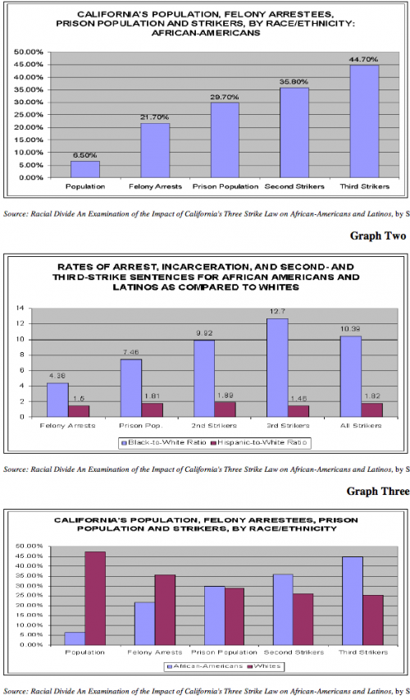](http://emsnews.files.wordpress.com/2012/04/screen-shot-2012-04-01-at-8-32-09-pm.png)

These graphs show how blacks are far more likely per population size, be involved in criminal actions and put in prison.  The War on Drugs impacts the black community very hard but then, many of the perpetrators are making money this way so it is no surprise to see these statistics.

Another thing is, whites doing drug dealing in white communities keep a much lower profile (less ‘on the street’ sales, of course).  The lure of the street dealing system is ripping apart black communities because, it being out in the open, more of them go to prison over time.

Now for a graph showing the disintegration of first, black families and increasingly, all families in our country due to the destruction of the ‘job for life’ system which unions created in the past:  [Out of wedlock childbirth » Graphic Sociology](http://thesocietypages.org/graphicsociology/2010/10/18/out-of-wedlock-childbirth/)

[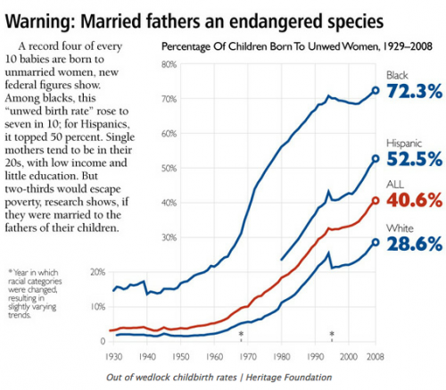](http://emsnews.files.wordpress.com/2012/04/screen-shot-2012-04-01-at-8-10-10-pm.png)

Anyone watching ‘Teen Mom’ on MTV can see how destructive this is in all communities.  Many of the males in these ‘life story’ shows have ended up in trouble due to illegal drugs (black and white boys) and the females are in and out of jail, too, or lose custody of their children over time.  Only one, so far, has given up her child for adoption.

[Adoption Statistics: Placing Children](http://statistics.adoption.com/information/adoption-statistics-placing-children.html)

The percentage of premarital births placed for adoption has decreased since the 1970s. Analyses of three cycles of the National Survey of Family Growth show the following trend:

From 1952 to 1972, **8.7%** of all premarital births were placed for adoption.  
From 1973 to 1981, this percentage fell to **4.1%.**  
From 1982 to 1988, it fell further to**2%.** (Bachrach, Stolley, London, 1992)

Less than 3% of white unmarried women and less than 2% of Black unmarried women. (Mosher and Bachrach, 1996)  
Of Black women with premarital births,  
From 1952 to 1972, **1.5%** placed their children for adoption.  
From 1973 to 1981, this percentage fell to**.2%**  
From 1982 to 1988, it rose to**1.1%.**

Of White women with premarital births,  
From 1952 to 1972, **19.3%** placed their children for adoption.  
From 1973 to 1981, this percentage fell to **7.6%.**  
From 1982 to 1988, it fell further to **3.2%.** (Bachrach, Stolley, London, 1992)

When they become pregnant, very few teens choose to place their children for adoption. In a 1995 survey, 51% of teens that become pregnant give birth; 35% seek abortions; 14% miscarry. **Less than 1% choose to place their children for adoption.** (ChildTrends, 1995)

One thing that many liberals love to say is, poor minority females don’t give birth to get more welfare money.  Well, I used to be a super in an apartment building in NYC in the past and yes, they did do this quite openly.  Proudly, even.  A parade of males would pass in and out of the lives of the women on welfare but they had their monthly payments from the government so there was no way in hell, they would put up the poor children for adoption.

Being ‘pay checks’ there was often few expressions of affection or even regard for raising the child so the kid would be functional or even safe.  So I called the Child Protection Services people pretty often.  Not to mention, feeding and giving medical attention to these pay check children.  Liberals like to think they are loving and kind but the welfare system, as it was run in the past, was just plain cruel.  And no one seemed interested in fixing it.  Nor do the conservatives want any sane fixes.

They want to go back to Jim Crow!